GREENSHEET HOW-TO

Due Date – Submit Greensheets within 3 business days of an offer being accepted
- Log into mykw.kw.com
- Hover over the black Technology tab

- Click on Greensheet in the dropdown
- Click on Create a Greensheet located at the top of the page
- Answer the first two questions (for manual entry answer NO to both even if the answer is yes)
  - If you answer yes to either or both questions you will be taken to the KWLS page to find that listing which will pull in some of the needed information and save you time. The fastest way to find a listing is filter by listing status Active (1), enter agent last name (2), hit search (3), then select the correct listing (4)

- Fill in each section of the greensheet – all RED fields are REQUIRED
  - Select from the drop down menus or enter the information manually for each required field. White fields are optional. Greyed out fields cannot be edited, applicable grey fields will autofill.
  - Enter all required info in each section then click Next Section
- General Information -
  - Greensheet type –Residential (most common) or Commercial
  - Contract Date and Close Date (use current settlement deadline)
  - Transaction – from drop down menus
    - Type – Listing Sold, Buyer Sale, or Both – DO NOT USE “Other”
    - Class – Property (most common) or Lease
    - Property Type – Resale (most common), New Build (common), Lot, Farm & Ranch, Lease
  - Property – enter info
    - Street – Number and first direction (i.e. 550 E)
    - Street Name – Name or Second Number (Broadway or 300 S)
    - City, State, Zip, County

- Price/Commission – Earnest/Escrow
  - Enter CURRENT Sale Price > Select Percentage or Flat > If percentage, enter the percentage for YOUR SIDE only, not the whole commission, if flat, enter the amount
  - Earnest money info is NOT required but is very helpful if you can enter it.
- Buyer and Seller – These can be as simple as the last names. What you put in here is what will show on the DA (disbursement authorization) which is your record of the transaction details so if you want first names to show you can enter them.

- Agent Detail Section:
  - KW Agent Name - if you are logged in to mykw your name will automatically fill in as Agent A
    - If you’re on a team, there might be Agent B, C, etc.
      - You cannot type a name in for Agent B, C, etc. – you must click on the magnifying glass and search for them by last name
    - If you are on both sides of the transaction (representing both buyer and seller on one property) you will enter yourself as Agent A and Agent B and assign one side of the transaction to each
  - Agent Role
    - Single Agents use Individual Agent
    - Team members use Buyer Specialist, Listing Specialist or Lead Agent
  - Type – Listing or Sale only – DO NOT USE INSIDE OR OTHER
  - Agency – Buyer, Seller or Dual (only if you are representing both sides on this transaction)
  - Listing Unit or Sales Unit – MUST Equal 1
    - one or both will be active (not greyed out) based on the transaction type you set in the first section
    - Single Agent will usually be 1 unless they are paying a referral to an agent in our market center. Then they may be .75 and agent B would be .25
    - Teams will enter the splits based on their specific team agreements (.5/.5, .7/.3, .6/.4, etc.)
    - If you are on both sides of the transaction you need to have a total of 1 Listing Unit and 1 Sales Unit
  - Agent Written Volume – will autofill – not editable
  - Gross Commission – will autofill based on above information but can be edited if there is a special commission arrangement that does not follow the split formula
  - Outside Referral: for a referral fee paid to anyone NOT in our market center
    - % - enter the referral percentage and the Outside Referral amount will autofill. If it is a flat fee you can enter it manually in the amount line
    - When you enter an outside referral % and/or amount you will be prompted to enter the outside referral information. This is located directly below the agent detail section.
      - YOU MUST provide Brokerage and Agent name, mailing address and Tax ID info (W9) and indicate which agent (A, B, etc.) is responsible for paying the referral amount
      - Get a W9 from the brokerage and send it to the MCA Office

  - MC Approved Concession to Buyer or Seller –
    - Keller Williams expects you to earn a full 3% on every deal (because we believe you deserve it!) but we realize that OCCASIONALLY you will have to make a concession to get a deal to close
    - In MOST cases, if you have to make a concession (pay for Home Warranty, pay repair fees, etc.) you can take it “off the top” and not pay your split on it.
    - If the MCA notices you doing this often, you may lose the privilege and would have to take concessions off AFTER paying your split

  - Bonus (Admin Fee) - If applicable, enter amount
    - “-- spilt with MC or 100% to agent” applies to the bonus amount – it is ALWAYS Split with MC. If you don’t change it I will and this will cause your final commission amount to be different from your calculation
  - % Agent Commission Split – this will prefill based on your agreed upon split.
    - Single agents are 70%, team members are 85%. Do not change this unless you know FOR SURE you are capped
  - Agent Commission Subtotal – amount will autofill
  - Agent Royalty Rate – ALWAYS 6% - do not change it!
    - Capped on Royalty – if you know you are capped on Royalty, select Yes. If not select No
  - Agent Royalty – amount will autofill based on rate and selection above
  - Inside Referral – DO NOT USE
  - Agent’s 1099/T4 Income – will autofill - if you did everything correctly this will show your taxable income
  - KW Cares Donation Section – notice this whole section is pink with red text – it cannot be left blank
    - KW Cares – tax deductible – 100% of donations go directly to help KW agents in need (Hurricane relief, floods, fires, cancer, etc.) Many agents give a flat amount per greensheet. If you want to set up an automatic donation email the MCA
    - KW Kids Can – tax deductible – “KW Kids Can is an educational 501(c)(3) nonprofit founded to engage the next generation of entrepreneurs and world leaders in conversations that matter. Our learning program, QL: A World-Changer Mindset, teaches young adults how to gain their edge in an increasingly competitive world. Students walk away with concrete tools that help them pursue the life they desire.”
    - KW Family Fund – NOT tax deductible – Scholarship to help agents pay for Family Reunion
    - BOLD Scholarship – NOT tax deductible – Provides scholarships for agents to attend BOLD
    - You are not required to donate but you must put a 0. These fields cannot be left blank
  - Buyer’s Home Warranty – NOT COMMON
    - Remember, In MOST cases, we allow you to take the concession “off the top” in the MC Approved Concession section above
  - Agent Concession to Buyer or Seller – NOT COMMON
    - Remember, In MOST cases, we allow you to take the concession “off the top” in the MC Approved Concession section above
  - Other Deductions:
    - Can only be used for Market Center Approved deductions
      - Transaction Coordinator – If you use our in house TC, we can pay them from your commission but we DO NOT track your payment for tax purposes
      - KW Midvale Cares – our local donation account – not tax deductible
  - Custom Deductions – E&O Insurance
    - $35 per transaction (can be split by team members)
    - Up to $595 per agent per CALENDAR year (Jan-Dec)
    - If one team member is capped on E&O the other still only pays half ($17.50)
  - Net Agent Check – if you filled in everything correctly this will be your check or direct deposit amount

- Co-Broker Section – GROW YOUR PROFIT SHARE!
  - If you enjoyed working with the other agent on this deal, enter their info here and the TL will contact them. If they join KW and name you as their sponsor you will earn PROFIT SHARE
  - Not Required
- Vendors – Not Required
- Notes – Helpful but Not Required 😊
  - If there is anything the MCA needs to know, enter the info here
- SUBMIT GREENSHEET
- Click then

- If you missed any required fields you will get an error message. You need to go back and fix the missing items and submit again

  - If you did everything correctly the status will change to Partially Accepted. Yay!

- You’re almost finished but DO NOT LEAVE THE PAGE YET! 😊
- Click Printable View

- The Greensheet will load on a page like the one below. Hit File > Print > Print to PDF (most modern computers have a PDF writer. If you do not have one you can install one for free http://www.cutepdf.com/Products/CutePDF/writer.asp)

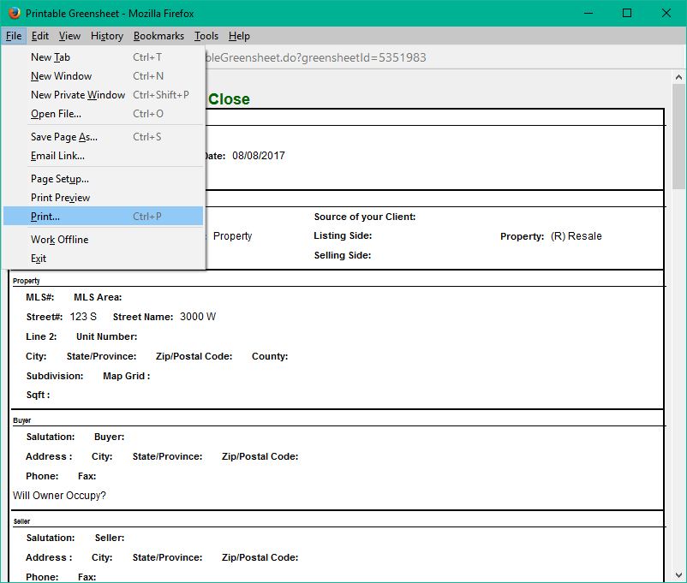
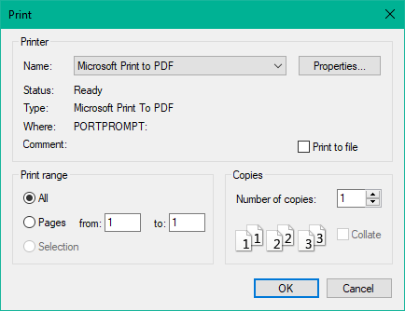

- Name the Greensheet - 550 e 2100 S;Greensheet and save it to a place you can find it easily (desktop)
- Add the Greensheet to the loop – See Dotloop 101 – Adding Documents
- You’re FINISHED!
- If contract CANCELS – please notify MCA by adding Notice of Cancellation to loop and resubmitting loop for review

